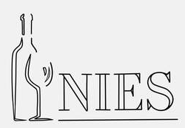
NIES Reservation form
Member cost $30.00
Guest Cost $35.00
Membership $25.00/year

Member(s) Name: _________________________________________________
Guest(s) Name: ___________________________________________________

Guest(s) Phone number: ___________________________________________________

Guest(s) Email: ___________________________________________________________

Mail checks to:
Linda Pendleton
6504 Brentwood Lane
Spirit Lake ID 83869
nieswinegroup@gmail.com

Reservations must be received no later than the Monday before the tasting.

*Per our bylaws anyone under the age of 21 may not attend NIES functions. Pursuant to Idaho Code Section 23-808, NIES is not allowed to serve alcohol to anyone who is intoxicated.

